10 Influential Women Share the Wellness Practices They Learned From Their Mothers
Well + GoodMay 7, 2015
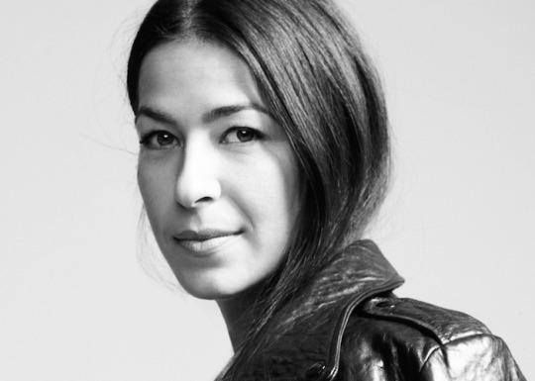
By Jamie McKillop for Well+Good
When it comes to beauty and wellness practices, chances are there’s something you do regularly that you learned from your mom (even if you did respond to it at the time by rolling your eyes—sorry, mom!).
RELATED: Are your beauty habits starting to look more like your grandmother’s?
And since Mother’s Day is about celebrating the women who gave us so much, we tapped inspiring, influential women—like Rebecca Minkoff, Linda Rodin, and Laurie David—to share the most meaningful practices and tips they inherited from their mothers.
Rebecca Minkoff
Designer
“When I was pregnant for the first time, my mom told me to alwaysknow when to stop and when to keep going in terms of balancing the growth of my business and family. It’s the best advice that keeps me focused on the important things in life and sane as a working mom. She also told me to laugh at yourself. It’s the best form of therapy, which is the ultimate wellness tip in my mind.”
RELATED: 5 Ayurvedic tips for de-stressing
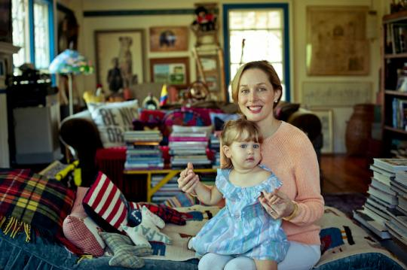
Tata Harper
Founder, Tata Harper Skincare
”Cranial sacral massage is a wellness practice that my mother shared with me that I’ve really found to be helpful. It’s not your typical form of massage that involves muscle work, it’s all about aligning your brain and spinal fluids. It’s mainly used to reduce stress and tension and to bring your energy back into alignment. The results are very mental. It’s so easy to get overly stressed about things that don’t really matter, so cranial sacral treatments help shift my brain back to a place where my priorities are aligned and my stress is reduced.“
RELATED: The five life-changing, stress-busting spa therapies you’ve got to try this season
Linda Rodin
Founder, Rodin
"My mother was a wonderful cook and very creative. She was a wonderful artist, interior designer, and owned a charming antique shop. I never remember my mother not wearing lipstick. Even driving us to school, in her night gown, she would have lipstick on. I guess I just saw early on how glamorous she always looked, and I caught the lipstick bug. I wear it always too and feel naked without it.”
RELATED: The 11 essential online beauty shops for natural and organic products
Sadie Lincoln
Founder, Barre3
“My mom has always worshiped sleep. Growing up she never woke me up from naps, even after school with homework due the next day, and she let me sleep in as long as I wanted. To this day, I’m a really good sleeper and I credit her for instilling this in me. She taught me a bedtime ritual of making a giant cup of tea like Sleepytime Extra or Kava Stress Release tea. She also taught me to keep a dream journal by my bed, and growing up we had a dream group with her friends. That taught me that dreams are very healing.”
RELATED: 7 easy things you can do for better sleep
Julie Greenbaum
Co-founder, Fuck Cancer
“The best wellness practice I learned from my mother was the ability to take away something worthwhile from every obstacle that comes my way. The raw openness she embraced her cancer with is something that will stay with me forever and an approach to life I try and use every day. This outlook has helped put things into perspective and has made me a healthier and happier person. It’s comforting to know that so many parts of her can still live on in me—definitely something I think a lot about on Mother’s Day.”
Laurie David
Author and producer
“My big takeaway from my mom is to entertain as often as possible. Card games, dinner parties, pool parties, holidays—even if it wasn’t our faith’s. She loved to entertain, and I do, too. I can still remember being given the honor of emptying the Waldbaum’s Bridge Mix from the box into her fancy glass bowl. That was always my job! How does entertaining connect with wellness? Well, when you entertain you laugh, smile, and have fun. To me that is one of the key pillars of good health.”
RELATED: This documentary will make you rethink your trip to the grocery store
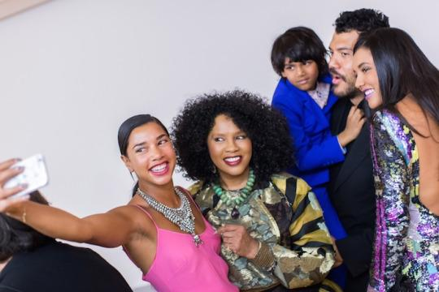
Hannah Bronfman
DJ, cofounder Beautified
“My mom is the most beautiful person on the inside, which makes her a magnet to all those who meet her! She taught me that the greatest thing you can possess is confidence and kindness. With those two things, everything is possible.”
Tricia Trimble
Founder, Suntegrity Skincare
“I learned from my Mom to apply a good sunscreen to the top of your hands on a daily basis. It’s meaningful to me because I lost my Mom to skin cancer that she first got on her left hand, and the doctors attributed it to sun damage that came in from the windows from many years of driving.”
RELATED: 7 simple summer beauty staples every woman must own
Latham Thomas
Founder, Mama Glow
“My mom taught me the value of self-care early on. She always said totake care of your body and learn to pamper yourself because it is a necessity for well-being. Skin care starts early with good products and hydration. We weren’t allowed to drink anything but water, no fruit juice, but fresh fruits, yes. My mom is well into her fifties and glowing. She has no wrinkles and doesn’t use makeup. No foundation, just lipstick. She would have my sister and I use shea butter andcoconut oil on our hands and feet and cover our feet with cotton socks before bed, and we would wake up with super soft feet and hands. The rudiments of my glow-time practice definitely started with these lessons.”
Brandy Monique
Founder, Fig+Yarrow
“My beautiful mother introduced me to the world of skin-care with two classics: an orange bar of Neutrogena soap and a blue bottle of Sea Breeze. These didn’t last long in my beauty repertoire, but my takeaway from this was the importance of starting skin care young. Appreciating the concept of beauty care at a young age and being a little nature-lover from the start prompted me to begin experimenting with flowers, spices, yogurt, honey, fruits, oils…whatever we had available to make my own beauty concoctions.”
More Reading from Well+Good:
Spring Serums: 7 new beauty elixirs for a fresh-faced glow
Will the Personal Care Products Safety Act make your beauty products any safer?
The 11 essential online beauty shops for natural and organic products
(Photos: Rebecca Minkoff, Tata Harper, Hannah Bronfman)

