A TISSUE PRESSURE MODEL FOR THE PALPATORY PERCEPTION
OF THE FREQUENCY OF THE CRANIAL RHYTHMIC IMPULSE

James M. Norton, Ph.D.
Professor of Physiology
University of New England College of Osteopathic Medicine
11 Hill's Beach Road
Biddeford, ME 04005
[207]283-0171

Abstract
Introduction
Development of the Model
Construction of the Model
Results
Discussion
References

ABSTRACT
A tissue pressure model was developed to provide a possible physiological basis for the manifestation of the Cranial Rhythmic Impulse, or CRI. The model assumes that the sensation described as the CRI is related to the activation of slowly adapting cutaneous mechanoreceptors, that the deforming forces stimulating these mechanoreceptors are the tissue pressures of both the examiner and the subject, and that the sources of changes in these tissue pressures are the combined respiratory and cardiovascular rhythms of both examiner and subject. This tissue pressure model utilizes well-documented relationships among vascular pressures, tissue pressures, and cardiovascular and respiratory rhythms. The model generates rhythmic impulses with frequencies and patterns similar to those reported for the CRI, and a significant correlation was found between frequencies calculated from the model and published values for CRI obtained using palpation. These comparisons suggest that the CRI may arise in soft tissues and represents a complex interaction of at least four different physiological rhythms.

INTRODUCTION
Rhythmicity appears to be an intrinsic property of many physiological regulatory systems. Most of these rhythms are endogenously generated by excitable tissues such as nerve and muscle or by hormonal mechanisms and are not merely responses to external environmental phenomena. In addition to rhythms or cycles contributing to homeostasis, very complex rhythmical processes are generated within the structures of the central nervous system which are associated with patterns of behavior such as locomotion and with arousal. The many and varied biological rhythms cover a broad range of cycle lengths and frequencies⁽¹⁾, as shown in Table I. Establishing causal relationships for each of these rhythmic processes is a major and continuing challenge for the physiological sciences.
The existence and nature of a rhythmic pulsation palpable on the external surface of the head of a living human subject, the Cranial Rhythmic Impulse (CRI), have been frequently described in the osteopathic literature. The CRI is generally considered to be similar to yet different from the rhythms of respiration and heart rate, with frequencies in the range of 6-12 cycles/min or 11-14 cycles/min^{(2),(3)}. The methods recommended for optimum palpation of the CRI in a human subject are well described, particularly with respect to the placement of the hands and the pressures to be applied during palpation. The CRI is best detected by "very light, passive (kinesthetic), bimanual palpation of the cranium" using the hypothenar and palmar portions of the hand rather than the fingertips⁽⁴⁾. The impulse is described as "resembling the respiratory excursion of the chest in minute form . . . registered in the motion-sensitive proprioceptors of the hands"⁽⁵⁾. Lightness of touch is emphasized as being essential to the detection and interpretation of the CRI⁽⁶⁾.
The field of cranial osteopathy in its broadest sense encompasses all aspects of the generation, sensation, and modification of the CRI:
Cranial osteopathy may be said to consist of four parts: (1) the tactual sensing of minute motions and asymmetrics of the live cranium; (2) Hypothesis concerning the source of the motion, the mechanism involved, and the norm of motion to be desired; (3) a body of knowledge associating variations from the norm of cranial motion with system malfunctions; (4) a body of manipulative technique for restoring the norm.⁽⁷⁾
Although progress is continuing to be made in the more clinical areas of palpatory diagnosis and treatment using cranial techniques, the source of the apparent motion and the mechanisms involved in its generation have not been adequately addressed by rigorous scientific investigation. However, if Ockham's razor is applied to the problem of the source of the perceived motion, the initial target for investigation becomes the point of contact between the subject and examiner, namely, the skin. From this starting point, any explanation of the genesis of the CRI must incorporate well-defined principles of vascular, microvascular and tissue pressures, the properties of cutaneous mechanoreceptors, the anatomical relationships among mechanoreceptors and vascular elements within the skin, and the possible contribution of clearly established physiological rhythms of similar cycle length (cardiovascular and respiratory) to the motion perceived and described by the examiner. Furthermore, any calculations of the frequency of variations in tissue pressure must be compared to actual measurements of CRI obtained using standard palpatory techniques in order for the validity of the model to be demonstrated.

DEVELOPMENT OF THE TISSUE PRESSURE MODEL FOR THE CRI
BASIC ASSUMPTIONS
The point of departure for the development of a tissue pressure model can be summarized as follows: 1) the CRI appears to be a form of low-amplitude rhythmic pulsation with a frequency range of 0.1-0.2 cycles/sec (see Table I); 2) the CRI is best palpated by very light touch utilizing kinesthetic or proprioceptive mechanoreceptors on the palmar and hypothenar surfaces of the hand, de-emphasizing sensory input from the fingertips; 3) the CRI does not appear to be synchronous with, or some harmonic of, either the cardiovascular or respiratory rhythms of the subject; and 4) the source of the movement is frequently linked to fluid motion within various body fluid compartments. The last three points will be discussed below in the context of three basic assumptions used in the development of the tissue pressure CRI model.
assumption #1: Cutaneous mechanoreceptors exist which are capable of responding to small displacements of the skin at a frequency range consistent with that reported for the CRI.
The tissue pressure model for the CRI has as one of its basic features the presence of mechanoreceptors in the skin of the human hand that are capable of picking up small movements displacing the surface of the skin, and of doing so at the frequencies and amplitudes ascribed to the CRI. Furthermore, to satisfy the requirements of the model, these receptors must be located in anatomical positions which make them subject to displacement due to vascular or tissue pressure changes in the tissues surrounding them as well as from external forces. The following discussion of cutaneous mechanoreceptors demonstrates that mechanoreceptors do exist in the human hand with the appropriate response characteristics and location, and is based on a recent review of the neurophysiological basis for the sense of touch⁽⁸⁾.
Four major morphologically distinguishable mechanoreceptors are found in the skin of the human hand. The most important epidermal sensory terminal consists of a specialized receptor ("Merkel") cell and an associated disklike nerve terminal. Three other types of sensory receptors also occur in primate skin: 1) Meissner's corpuscles, found in the papillary layer of the dermis; 2) Ruffini corpuscles, also found in the dermis and essentially identical in structure to Golgi tendon organs; and 3) Pacinian corpuscles, located deeper within the dermis and underlying tissue. Neurophysiological research has allowed each of these four morphologically distinguishable receptors to be identified with one of the four functionally distinct groups of mechanoreceptor afferent fiber types. Table II summarizes these relationships as they are presently understood.
Quickly-adapting mechanoreceptor fibers are of two types. QA fibers (associated with Meissner's corpuscles) are the most common and are velocity-sensitive, responding to displacements in the velocity range of 2-40 mm/sec but not responding to constant, steady displacement. Pacinian fibers are the least common type, and respond to high-frequency (200-300 Hz) vibratory stimuli, complementing the 20-40 Hz response range of the QA fibers. Slowly adapting fibers are also of two major types, both of which respond not only during the process of indentation of the skin but also during sustained steady indentation, even when the displacement of the skin is less than 100 microns in magnitude. SA I fibers (associated with Merkel cells) are more responsive to indentation than SA II fibers (associated with Ruffini end organs), and are less likely to exhibit spontaneous discharge in the absence of mechanical stimulation of the skin. Both types of SA fibers are associated with the skin of the palm, the portion of the hand recommended for optimal palpation of the CRI as described above. Considering the location, structural properties and functional characteristics of the major mechanoreceptors of the human hand, it would seem likely that the sensation of rhythmic cranial motion with a frequency of 0.1-0.2 Hz experienced during light contact of the examiner's hand with the subject's head would be initiated by activity in the SA fibers, particularly those associated with Merkel cells. The possible involvement of the Ruffini end organs, however, and their similarity to Golgi tendon organs, supports the "proprioceptive" nature of the sensations resulting from cranial palpation.
assumption #2: The deforming forces acting upon the cutaneous mechanoreceptors to produce the sensation of motion are the fluid pressures within the cutaneous tissues of both the examiner and subject.
The Merkel cells and their associated nerve terminals are located at the border of the epidermis and dermis within the epidermal basement membrane, and superficial to the major vascular structures in the skin: arterioles, arteriovenous anastomoses, and the subcutaneous venous plexuses. So located, Merkel's disks would be subject to deforming forces arising from both the surface of the skin (external deformation) and from changes in tissue pressure within the dermis itself (internal deformation). With the hands in the position recommended for optimal palpation of the CRI, the SA I mechanoreceptors of the examiner's palm would be exposed simultaneously to an external deforming force related to the tissue pressure exerted by the scalp of the subject and an internal deforming force produced by the tissue pressures within the examiner's palm itself. The extent of deformation would therefore be determined by the relative magnitudes of these two tissue pressures, the examiner's and the subject's. The following discussion focusses on fluid pressures and movements within tissues, with the aim of providing basic quantitative relationships that serve as the foundation for the mathematical aspects of the tissue pressure model for the CRI.
A tremendous body of literature exists with respect to the origin, characteristics, magnitude, and control of intravascular pressures at all levels of the circulatory system. A similarly large body of literature deals with the exchange of fluids across capillary endothelium and the regulation of tissue pressures. In the following paragraphs, no attempt will be made to summarize these general fields, but a recent review of the field will be utilized to outline the general concepts of vascular and tissue pressures, to support the development of a theoretical model, and to provide for the selection of "default" values for a number of parameters used by the model⁽⁹⁾.
Variations in tissue volume and pressure could arise from changes in either the volume of blood within a tissue, the volume or pressure of the interstitial fluid within that tissue, or some combination of these. Exchange of fluid within tissue between the intravascular and interstitial compartments occurs by ultrafiltration across microvascular walls, particularly those of capillaries and postcapillary venules. Ultrafiltration exchange is governed by the balance of hydraulic and oncotic forces across the wall of exchange vessels and the hydraulic conductivity of these walls, as expressed by the modern version of Starling's hypothesis:
J_{s} = L_{p}S[(P_{c}-P_{isf})-s(O_{p}-O_{isf})]
eq. 1
where J_{s} is net rate of fluid movement, L_{p}S is the hydraulic conductivity-surface area product, P_{c} is mean microcirculatory pressure, P_{isf} is mean interstitial fluid pressure, s is the reflection coefficient for plasma proteins, O_{p} is the oncotic pressure for plasma, and O_{isf} is the oncotic pressure in the interstitial fluid. The parameter most likely to determine the overall magnitude of the exchange process within the time period of the CRI is P_{c}; this mean microcirculatory pressure can be related to pressures in large arteries (P_{a}) and large veins (P_{v}) using the following expression:
P_{c} = [P_{a}(R_{v}/R_{a})+P_{v}]/[1+(R_{v}/R_{a})]
eq. 2
where R_{v} is post-capillary vascular resistance, R_{a} is pre-capillary vascular resistance, and where R_{a}+ R_{v} = R_{total}. From these two expressions, it can be seen that the vascular and interstitial fluid volumes within a tissue represent at any moment the balance between fluid movement into and out of the exchange vessels, which in turn depends on the relative pressures in large arteries and veins and the ratio of pre- and post-capillary vascular resistances. Furthermore, mean microcirculatory pressure, P_{c}, is affected by a greater degree by fluctuations in venous pressure, since exchange vessels are "protected" from the high arterial pressures by a relatively high pre-capillary vascular resistance residing at the level of the small muscular arterioles. This is evident in equation 2 above in that the effects of changes in P_{a} will be reduced by the ratio R_{v}/R_{a}.
In addition to the dominant effect of venous pressure on microcirculatory pressures and capillary exchange, the portions of the vasculature within a representative tissue such as the scalp which are responsible for the greater part of active and passive volume changes are the venules and small veins, due to the relatively large resting volume and high compliance of these vascular segments. Fluctuations in venous pressure would therefore be expected to alter tissue fluid pressure not only directly by affecting blood volume and pressure in venules and small veins, but also indirectly by affecting microcirculatory pressures and the distribution of fluid between the vascular and extravascular spaces.
assumption #3: The CRI is a complex function of the respiratory and cardiovascular rhythms of both the subject and the examiner.
The CRI has not been considered by those experienced in cranial palpation either to be synchronous with or to be an harmonic of the cardiovascular or respiratory rhythms of the subject. These types of empirical observations do not in themselves rule out a complicated relationship between these physiological rhythms and the CRI, however, especially when the participation of two individuals, examiner and subject, is considered. Such a complex relationship may not be obvious to even a practiced observer. The intriguing possibility that the CRI represents a combination of physiological rhythms from both participants in the palpatory process was actually quite clearly articulated nearly twenty years ago:
It can be shown mathematically that if the pressure-sensing nerve ends are acted upon by the sum of two oscillatory pressures of different frequency, and if the effective signal developed by the nerves is a nonlinear function of the total pressure, then the signal will contain two pseudo-oscillations of which the frequencies are the sum and the difference of those actually present. Further if the neural networks are developed by attention and practice to filter out all but the lowest frequency, the sense of touch will experience the illusion that a repetitive motion is clearly felt at a frequency which is the difference between the two frequencies actually present. In palpation, the fingertips are subjected to four cycle motions of different frequency, one each from the pulse and respiratory cycles of the operator and of the subject. It may be contended with some force of argument that the apparent sensation of a slow cranial rhythm represents only a "beat" frequency between, say, the two pulse cycles.⁽¹⁰⁾
This very reasonable and quite physiological approach to explaining the frequency of the CRI was not rigorously pursued and the methods and data described in the study from which the above quote was taken neither validate nor refute this hypothesis. The experimental conditions under which the CRI was measured in the study were not comparable to the palpatory methods used clinically, since the investigators utilized force/displacement transducers ("pickoffs") forcefully applied to the sides of the head of the subjects. Although the force was considered sufficient to eliminate the contribution of vascular and tissue pressures within the scalp of the subject, a rhythmic pattern of motion was nevertheless recorded. The source of these "movements" and their relationship to the CRI palpated by examiners using very light touch was left unresolved. The strong argument for implicating known physiological rhythmic processes into the explanation of the genesis of the CRI seemed to remain unanswered and was incorporated into the tissue pressure model described here.

CONSTRUCTION OF THE MODEL
Given the assumptions and mathematical relationships described above, a relatively simple computer model was developed which would allow the determination of the net deforming force produced by tissue pressures on the mechanoreceptors in the skin of an examiner's hand in the presence of rhythmically changing arterial and venous pressures in the skin of both examiner and subject. In this model, baseline values for heart rate (HR_{o}) and respiratory frequency (RF_{o}) can be arbitrarily assigned to both the subject and the examiner. Default values were chosen for the following parameters for both subject and examiner: P_{a}, 85 mm Hg; P_{v}, 10 mm Hg; and the ratio R_{v}/R_{a}, 0.1; these were based on measurements of pre- and post-capillary pressures and resistances measured in mammalian skin using micropuncture and the isogravimetric or isovolumetric method⁹.
Sinusoidal functions were used to approximate the rhythmic fluctuations in arterial and venous pressures. Frequencies were equal to the heart rate and respiratory rate, respectively; amplitudes represented reasonable values for pulse pressures in small arteries (+/- 20 mm Hg around the mean) and for the pressure fluctuations in large veins (+/- 3 mm Hg around the mean). The source of the rhythmic changes in arterial pressure was assumed to be the pumping action of the heart; the source of the rhythmic changes in venous pressure was considered to be the fluctuations in intrathoracic pressure produced during the respiratory cycle, transmitted in a retrograde fashion into the large peripheral veins.
To simulate the natural variability present in the physiological rhythms of a living organism, heart rate and blood pressure were linked to the respiratory cycle to simulate the normal increases and decreases that occur in each with inspiration and expiration^{(11),(12)}. In addition, the length of each respiratory cycle was allowed to vary randomly within +/-10% of the baseline value, 1/RF_{o} (see Figure 1). It is precisely the presence of this kind of underlying physiological variability in the cardiovascular and respiratory rhythms that would make correlation of the CRI with these rhythms in a human subject extremely difficult; conversely, the incorporation of this variability into the proposed CRI model strengthens the validity of the model and of any correlations obtained through its application.
Once loaded with operator-determined initial values for heart rate and respiratory frequency, the tissue pressure model calculates P_{a}, P_{v}, and P_{c} at 0.05 sec intervals independently for the examiner and the subject, and estimates the net deforming force (P_{net}) on the mechanoreceptors of the examiner as the difference between P_{c[examiner]} and P_{c[subject]}. The P_{net} curve is continuously smoothed by a time-averaging algorithm that mimics the response characteristics of the SA II mechanoreceptor fibers. The results are displayed in a graphical format, with a time "window" specified by the operator (10 sec, 3 min, etc.). The model parameters that can be displayed are a representation of the respiratory excursions of the subject and/or examiner, P_{c} for subject and/or examiner, and P_{net}; this flexibility allows the output of the model to be made similar to graphs and charts found in the literature on this subject. Calculated frequencies for variations in P_{net}, the overall force within the tissues responsible for the deformation of the mechanoreceptors, will be hereafter be compared to palpated frequencies of the CRI; the frequency of the P_{net} curves generated by the model is determined simply by counting the major peaks over a known time period.
The net deforming force, P_{net}, was calculated in a variety of different ways, incorporating not only mean microcirculatory pressure, P_{c}, but also P_{a} and P_{v} in various proportions. The microvasculature is a mixture of small arterioles, capillaries, and venules, and it was felt that the net vascular pressure ought to include all three components. Preliminary runs of the model, however, showed that inclusion of P_{a} and P_{v} along with P_{c} did not affect the frequency of the calculated CRI, but only its magnitude; for simplicity, therefore, only values for P_{c} of examiner and subject were used in the calculation of P_{net} in this report.

RESULTS
PATTERNS GENERATED BY THE TISSUE PRESSURE MODEL
The computer model generates a rhythmic pattern in P_{net} that is similar to but not synchronous with the respiratory rhythm assigned to the subject (see Figure 2, upper panel). No two sets of curves generated by the model look exactly alike, even with the operator-defined variables held constant, a result of the randomization of respiratory cycle lengths. In addition, the observed P_{net} frequencies differ slightly with repeated runs of the model; the average frequency for ten repetitions of a standard set of values for heart rate and respiratory frequency for subject (60/min and 12/min, respectively) and examiner (72/min and 15/min, respectively) was 11.39/min with a standard deviation of 1.17. This frequency is similar to, but slower than, the respiratory frequency of the subject, a finding noted clinically¹⁰. The random variation in respiratory cycle length and the resulting effects on heart rate and arterial pressure built into the model also avoid the obvious synchronicity that would otherwise occur if heart rates and respiratory frequencies were the same for the subject and examiner (Figure 2, lower panel).
COMPARISON OF MODEL-GENERATED P_{net} PATTERN WITH PUBLISHED CRI PATTERN
Figure 3 is a comparison of a recording of the CRI in a human subject utilizing force/displacement transducers¹⁰ (upper panel) and respiratory cycles and calculated P_{net} generated using the tissue pressure model (lower panel). In order to make the model calculations comparable to the situation described in the experimental study, where mechanical "pickoffs" replaced the hands of the examiner, a variation of the basic tissue pressure model was used to generate the pattern shown in the lower panel, one that incorporated only the subject's heart and respiratory rates. Since the sensing of CRI in the study was done mechanically, there would be only two physiological rhythms contributing to the CRI, the cardiovascular and respiratory rates of the subject. The time scale was omitted from the original figure in the reference, but the ratio of heart rate to respiratory frequency in the original figure (4.25:1) was used to produce the output from the model. The mechanical displacement patterns measured in the study and the tissue pressure patterns calculated using the model are very similar, strongly suggesting that a combination of well-known rhythmic processes could explain the pattern generated by the transducers used in the study as well as the CRI perceived through palpation.
COMPARISON OF CALCULATED P_{net} FREQUENCIES WITH PUBLISHED VALUES FOR PALPABLY MEASURED CRI FREQUENCIES
The tissue pressure model for the generation of P_{net} curves was tested against the only complete set of data from the literature available to this author relating cardiovascular and respiratory rates for subjects (in this case, pre-school children) and examiners to recorded values for the CRI of the subject⁽¹³⁾. The respiratory frequencies and heart rates listed for each of the 50 determinations of the CRI were entered into the model and values for P_{net} frequency were calculated by counting the major peaks during a 60 sec run of the model. Figure 4 is a graphical representation of the significant (p<.05) correlation between the published palpably measured CRI frequency and the P_{net} frequency generated by the model. Individual comparisons between P_{net} frequency and heart rates or respiratory frequencies revealed only one significant correlation, and that was between the P_{net} frequency calculated using the model and the respiratory frequency of the examiner (r = .745, t = 7.7565 for 48 d.f., p<.001). This finding suggests that the CRI perceived by the examiner is influenced relatively more by the examiner's own physiological status than by the subject's. This possible conclusion was supported by multiple regression analysis using the SYSTAT® statistics package, which yielded the following regression equation:
P_{net} frequency = 0.792 -.022*HR_{s} + .139*RF_{s} + .008*HR_{e} + .734*RF_{e}
where HR_{s} and RF_{s} are heart rate and respiratory of the subject, and HR_{e} and RF_{e} are the corresponding values for the examiner. The regression coefficient (R²) was 0.610; the most significant predictors of P_{net} frequency were the respiratory frequencies of the subject (RF_{s}, p<.05) and of the examiner (RF_{e}, p<.001).
No significant individual correlations could be found between the palpated CRI frequency and the heart rates or respiratory frequencies of the subjects or the examiners, confirming the anecdotal observations that no such correlations can be detected. Again using SYSTAT®, the following regression equation was obtained:
CRI frequency = 12.65 + .001*HR_{s} + .021*RF_{s} - .063*HR_{e} + .210*RF_{e}
The regression coefficient (R²) was 0.069, and none of the measured heart rates or respiratory frequencies were significant predictors of the measured CRI frequency, once again supporting the clinical observations in this regard.

DISCUSSION
COMPARISON OF PATTERNS
Figure 3 represents a comparison between a recording of the CRI and the pattern generated by the tissue pressure model. In the reference on which the upper panel based¹⁰, the correlation between respirations and cranial movements was described as "highly erratic"; at another point the cranial rhythm is described as "independent" of respiration. Inspection of the upper panel of Figure 3 shows only one major peak of the cranial tracing that is not associated with a respiratory excursion (the third from the left). If the curved stylus paths evident in the recordings is taken into account when determining correspondence between respiratory and cranial movements (which the author did not do), the peak of nearly every respiratory excursion is near the highest point of the corresponding cranial movement wave. Both the experimental and computed respiratory excrusions in Figure 3 show variation in the respiratory cycle length; in fact, the variation is greater in the living subject than in the model. In the model, the contribution of the arterial pressure pulses associated with heart rate can be made more or less prominent by varying the ratio of pre- and post-capillary resistances, R_{v}/R_{a}. An increase in R_{v}/R_{a} would increase the magnitude of the arterial pressure pulses and provide an even greater degree of similarity between the mechanical displacement pattern obtained using the "pickoffs" and the P_{net} pattern calculated from the model. In a living subject, increased cutaneous blood flow rate accomplished by arteriolar vasodilatation in the warm skin at the point of contact between subject and examiner would also increase this ratio and make the cardiovascular pulses larger.
COMPARISON OF PALPATED CRI FREQUENCIES AND P_{net} FREQUENCIES GENERATED BY THE TISSUE PRESSURE MODEL
Some of the respiratory frequencies and heart rates of the young subjects used in the comparative study of respiratory, cardiovascular, and CRI frequencies¹³ were high even for pre-school children. The simultaneous presence of elevated heart rates and respiratory frequencies in some of the examiners as well suggests that neither the children nor the examiners may have been completely relaxed during the procedures. Nevertheless, the correlation between palpated CRI frequencies and calculated P_{net} frequencies was statistically significant, lending support to the validity of the model. Data from a similar study using adult subjects would be an excellent future test of the tissue pressure model.
RELATIONSHIP OF THE MODEL TO CRANIAL OSTEOPATHY
The tissue pressure model described in this report is in no way intended to minimize the importance of measurement of physiological rhythms using the technique of cranial palpation. A tremendous amount of information can be obtained by a skilled examiner through palpation of a subject. Sensory input related to the temperature, texture, movements, and pressures within the tissues of a subject obtained through palpation are combined with information from other sensory modalities to provide a complex picture of the subject's physiological state. Much of the sensory input and integration takes place below the level of consciousness, however, and part of the difficulty in discussing the results of palpation may be due to the non-verbal character of much of the process of arriving at a palpatory diagnosis.
Teaching palpation of the CRI includes training the examiner to reach a relaxed, steady state in which attention is focussed on the sensory input from the points of contact with the subject. The goal of this training is to produce in the examiner a constant, reproducible physiological state of relaxation each time a cranial palpation is performed. If an examiner is completely successful in accomplishing this goal, the only source of variability in the frequency of the CRI lies with the physiological rhythms of the subject. Therefore, if a subject's CRI frequency is shown to vary in repeated determinations over weeks or months, it is highly likely that the variability actually reflects changes in the physiological state of the subject and can be legitimately used in conjunction with other information for diagnostic purposes. Similarly, the determination of different CRI frequencies in a number of subjects by the same examiner reflects the combination of different heart rates and respiratory frequencies in the subjects with a constant set of corresponding rhythms in the examiner. Again, the variability truly lies within the subject population. The model also begins to explain why different examiners often do not agree in their determination of the CRI frequency on the same subject, since the resting heart rates and respiratory frequencies of the examiners may be quite different.
Indirect support for the hypothesis that tissues pressures combine to produce the CRI also comes from the frequent observation⁽¹⁴⁾ that although the CRI is most easily palpated over the cranium and sacrum, it may be felt by an experienced examiner anywhere in the body. Both the cranial and sacral regions are characterized by a relatively thin layer of tissue overlying a relatively flat bony surface; this arrangement would optimize the ability of even a novice examiner to perceive changing tissue pressure and volume. When palpatory skills and the ability to concentrate on the appropriate sensory input are fully developed, as they are in a skilled examiner, the subtle changes in tissue pressure resulting from the interaction of cardiovascular and respiratory rhythms may very well indeed be felt without the benefit of having an underlying bony substrate present.
The model provides a plausible hypothesis for the perception of the CRI, albeit one that differs from that currently accepted by practitioners of cranial osteopathy. But in its reliance on basic physiological rhythms and on the importance of the interaction between subject and examiner, this new model underscores the relevance and importance of diagnostic information and impressions gained from skilled palpation. Osteopathic physicians generally regard each interaction between physician and patient as unique, and the tissue pressure model described in this report enhances rather than contradicts this notion. A diagnostic tool that incorporates a melding of physiological rhythms from two individuals would seem to approach the ideal of physician/patient communication that lies at the heart of Osteopathic medicine.
Application of this model to the palpation of the CRI in adult subjects is beginning, and the anticipated lower heart rates, lower respiratory frequencies, and higher degrees of cooperation and relaxation should allow more reliable determinations of CRI to be performed. Hardware and software are being developed to provide a real-time generation of P_{net} using data from subjects and examiners for direct comparison to the CRI as palpated by experienced examiners. The tissue pressure model proposed here has, however, already provided a reasonable and testable hypothesis regarding the physiological mechanisms underlying the perception of the Cranial Rhythmic Impulse.

TABLE I
COMPARISON OF THE CRI WITH
FAMILIAR MAMMALIAN BIOLOGICAL RHYTHMS
RHYTHM CYCLE LENGTH FREQUENCY (cycles/sec)
EEG 0.1 sec 10¹
heart rate 1 sec 10⁰
respiration 6 sec 1.67*10⁻¹
CRI 5-12 sec 0.83-2.0*10⁻¹
sleep stages 90 min 1.85*10⁻⁴
sleep/wake 24 hr 1.15*10⁻⁵
menstrual 28 days 4.13*10⁻⁷
hibernation 365 days 3.17*10⁻⁸

TABLE II
CORRELATION OF MECHANORECEPTORS AND THEIR AFFERENT FIBER TYPES
QUICKLY ADAPTING
QA Meissner's corpuscles
Pacinian Pacinian corpuscles
SLOWLY ADAPTING
SA I Merkel's disks
SA II Ruffini end organs

Figure 1
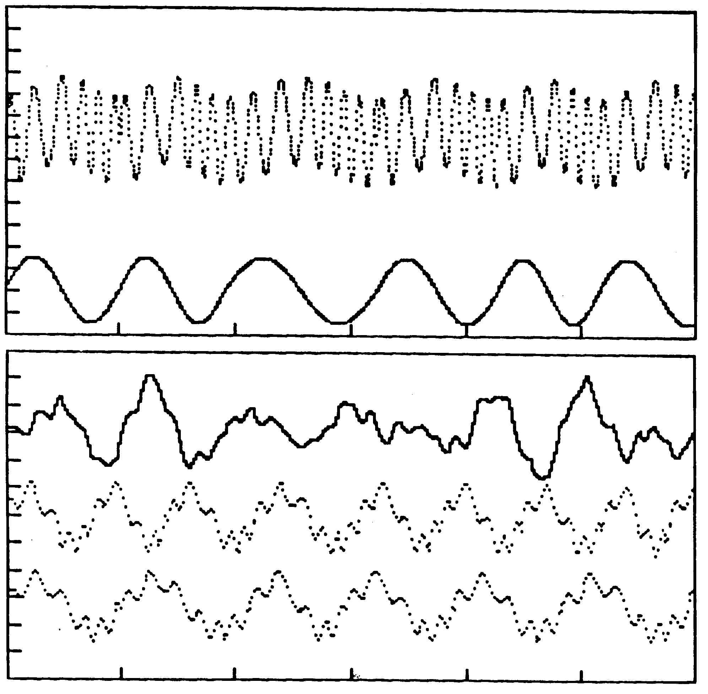
Legend for Figure 1
upper panel: Curves representing arterial pressure (upper curve) and respiratory movements (lower curve) over a 30 sec period as generated by the computer model, showing the variability in the length of the respiratory cycles and the effects of ventilation on arterial pressure and heart rate. Tic marks on the abscissa indicate 5 sec intervals; the vertical axis is arterial pressure, 0-150 mm Hg, with 10 mm Hg intervals. lower panel: Curves representing calculated P_{net} (top), and calculated P_{c} for subject, middle, and P_{c} for examiner, bottom, over a 30 sec period. The curves have large fluctuations in the same frequency range as respiration with a superimposed smaller, higher frequency variations related to heart rate.

Figure 2
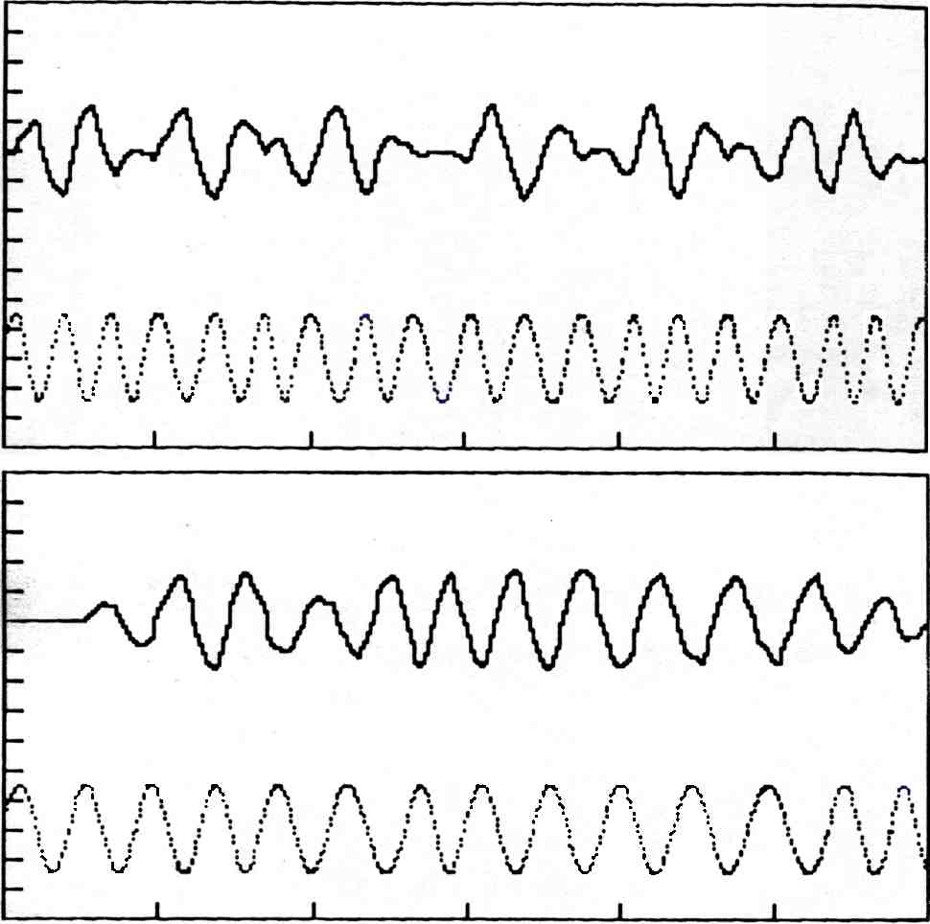
Legend for Figure 2
upper panel: A typical run of the tissue pressure model for a time period of 60 sec, showing the general nature of the rhythmic fluctuations in P_{net} (upper curve) and their relationship to the subject's respiratory cycle (lower curve). lower panel: Results using the tissue pressure model when the heart rates and respiratory frequencies for the subject and examiner are identical, showing that after the first respiratory cycle, synchronicity disappears and the P_{net} curve (upper curve) is no longer flat. The lower curve represents respiratory movements of the subject.

Figure 3
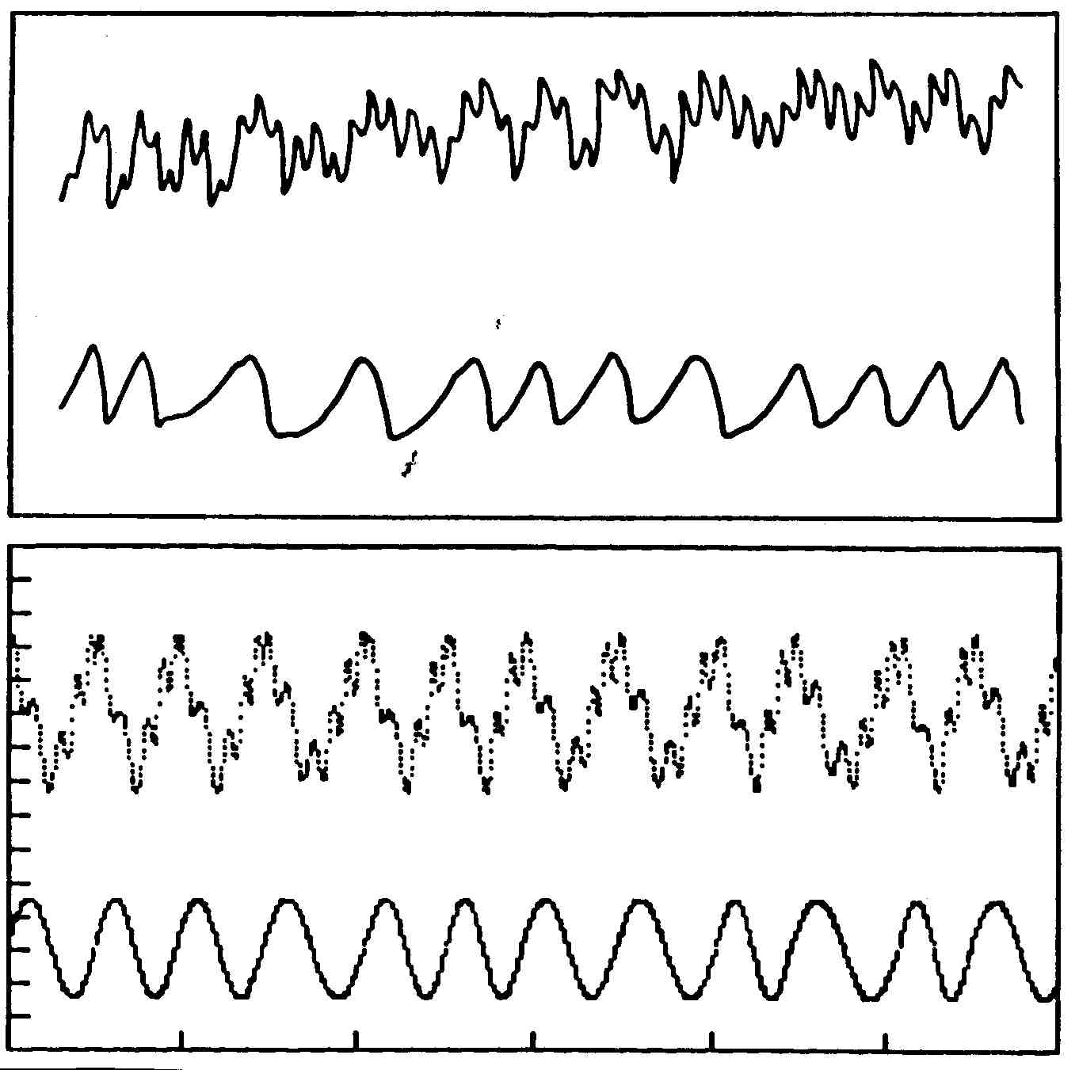
Legend for Figure 3
upper panel: The mechanical displacement [upper tracing] measured and recorded using a mechanical transducer compared to the simultaneous respiratory excursions [lower tracing] of the same subject (redrawn from Frymann, 1971). lower panel: P_{net} curve [upper tracing] and respirations [lower tracing] generated using the tissue pressure model. For further discussion, see text.

Figure 4
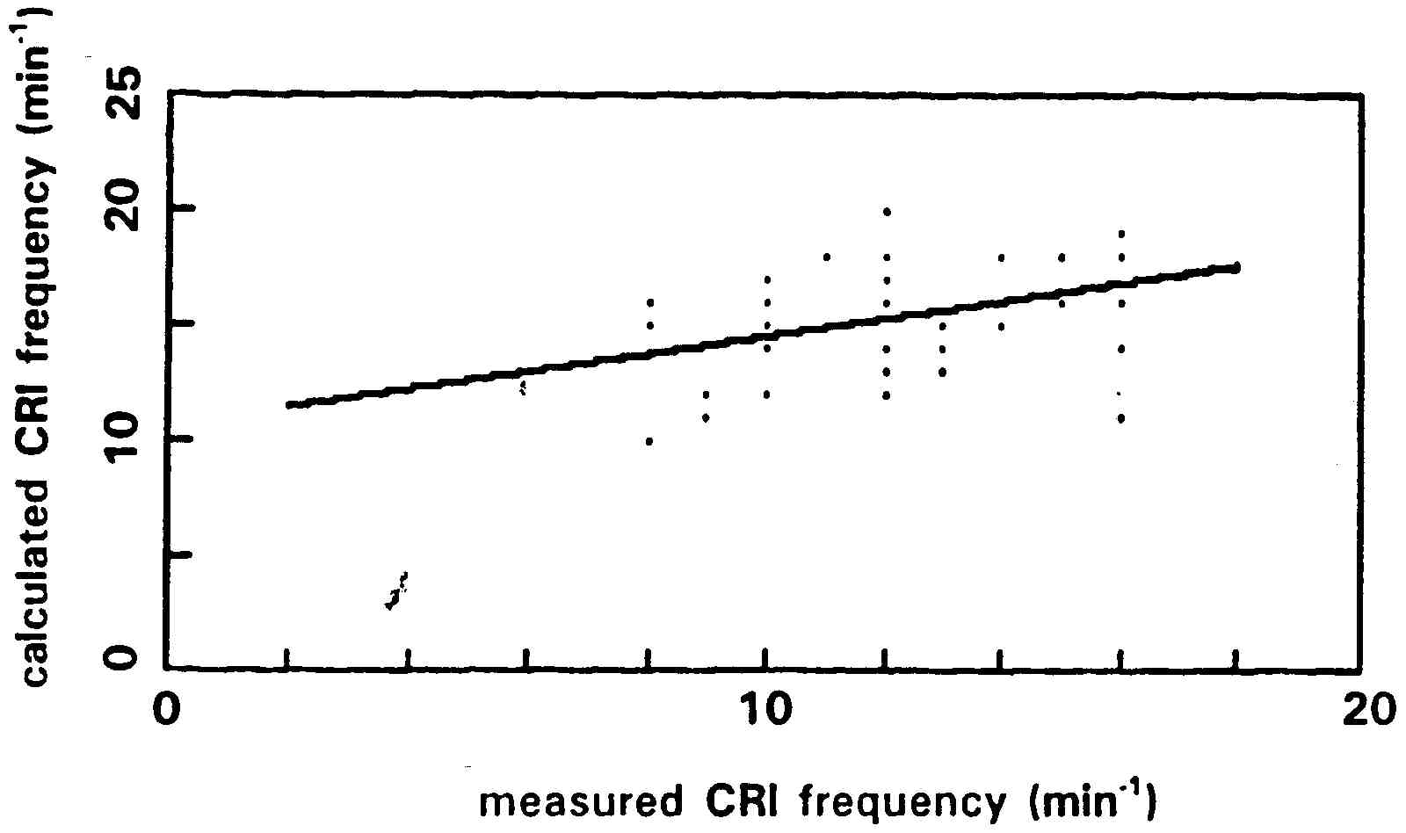
Legend for Figure 4
A comparison of CRI frequencies measured using palpation and calculated CRI frequencies from the tissue pressure model (P_{net} frequencies) as outlined in the text. The correlation coefficient (Pearson's r) = 0.314 (n = 50), t = 2.2931 for 48 degrees of freedom, p<.05.

REFERENCES
1. Lydic, R. Central pattern-generating neurons and the search for general principles. FASEB J. 3:2457-2468, 1989.
2. Upledger, J.E., and J.D. Vredevoogd. CraniosacralTherapy. Chicago: Eastland Press, 1983, p. 6.
3. Kappler, R.E. Osteopathy in the cranial field: its history, scientific basis, and current status. The OsteopathicPhysician February 1979, pp. 13-18. reprinted inClinicalCranialOsteopathy: SelectedReadings, R.A. Feely, ed., Meridian, Idaho: The Cranial Academy, 1988, pp. 2-5.
4. Woods, R.H., and J.M. Woods. A physical finding related to psychiatric disorders. JAOA 60:988-993, 1961, reprinted in Clinical Cranial Osteopathy: SelectedReadings, R.A. Feely, ed., Meridian, Idaho: The Cranial Academy, 1988, pp. 134-139.
5. Magoun, H.I., ed. Osteopathy inTheCranialField, Kirksville: The Journal Printing Company, 1976, p. 86.
6. Magoun, H.I., ed. Osteopathy inTheCranialField. Kirksville: The Journal Printing Company, 1976, p. 83.
7. Steele, F.G. Lecture given at the Cranial Conference, Kirksville, Missouri, April 1965, quoted in Osteopathy inTheCranialField, H.I. Magoun, D.O., ed., Kirksville: The Journal Printing Company, 1976, p. 320.
8. Darien-Smith, I. The sense of touch: performance and peripheral processes. in Handbook ofPhysiology, Bethesda, MD: American Physiological Society, 1984, Section I: The Nervous System, Volume III: Sensory Processes, Part 2, pp. 739-788.
9. Renkin, E.M. Control of microcirculation and blood-tissue exchange. in Handbook ofPhysiology, Bethesda, MD: American Physiological Society, 1984, Section 2: The Cardiovascular System, Volume IV: Microcirculation, Part 2, pp. 627-687.
10. Frymann, V.M. A study of the rhythmic motions of the living cranium. JAOA 70:928-945, 1971, reprinted in ClinicalCranialOsteopathy, R.A. Feely, ed., Meridian, Idaho: The Cranial Academy, 1988, pp. 31-44.
11. West, J.B., ed. Best and Taylor'sPhysiologicalBasisofMedicalPractice. Baltimore: Williams and Wilkins, 1985.
12. 12. Berne, R.M., and M.N. Levy, eds. Physiology. St. Louis: The C.V. Mosby Company, 1988.
13. Upledger, J.E., and J.D. Vredevoogd, op.cit., p. 351.
14. Norton, J.M. anecdotal information from students and osteopathic physicians who teach and practice cranial therapy.

